Mobile Product Reporting

super john

Thursday, May 07, 2015

## last_updated  
## 1 2015/5/11

Mobile Sold-As Monthly Revenue and Cost Summary

Represents as media sold-as mobile to client.

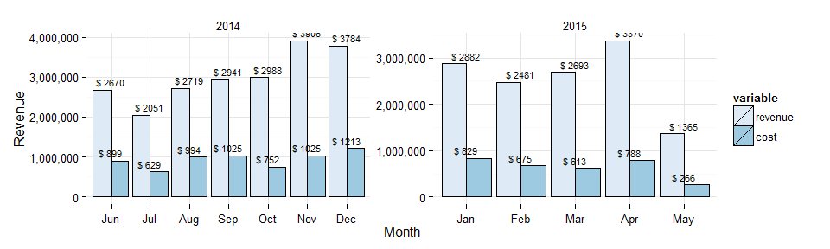

|  |  |  |  |  |  |
| --- | --- | --- | --- | --- | --- |
| month_year | projected_revenue | projected_cost | margin | count_campaigns | avg_daily_revenue |
| June 2014 | 2,669,558 | 898,852 | 0.66 | 353 | 88,985 |
| July 2014 | 2,051,081 | 629,107 | 0.69 | 365 | 66,164 |
| August 2014 | 2,718,823 | 994,486 | 0.63 | 369 | 87,704 |
| September 2014 | 2,941,439 | 1,024,810 | 0.65 | 428 | 98,048 |
| October 2014 | 2,988,300 | 751,577 | 0.75 | 424 | 96,397 |
| November 2014 | 3,905,940 | 1,025,475 | 0.74 | 429 | 130,198 |
| December 2014 | 3,784,057 | 1,212,604 | 0.68 | 411 | 122,066 |
| January 2015 | 2,881,510 | 828,607 | 0.71 | 371 | 92,952 |
| February 2015 | 2,480,584 | 675,440 | 0.73 | 328 | 88,592 |
| March 2015 | 2,693,306 | 612,737 | 0.77 | 374 | 86,881 |
| April 2015 | 3,370,386 | 788,049 | 0.77 | 458 | 112,346 |
| May 2015 | 3,847,987 | 750,054 | 0.81 | 401 | 124,129 |

Daily Revenue Trend

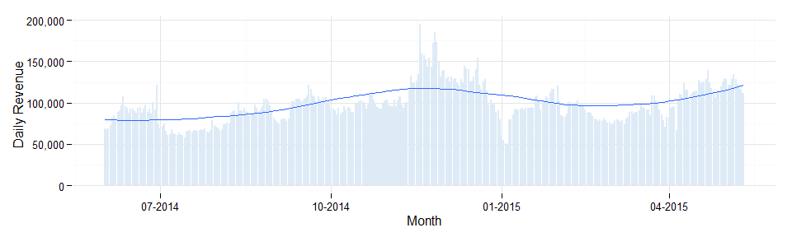

Regional Summary

year month Central Channel East EMEA Enterprise Japan West  
----- ------ ---------- ---------- ---------- ---------- ----------- ---------- ---------- 2014 6 700,705 29,090 979,758 109,814 107,191 2,909 711,455 2014 7 573,762 143,316 691,510 134,342 52,268 2,785 442,570 2014 8 477,540 135,435 1,124,351 144,897 67,447 6,049 747,352 2014 9 545,042 111,094 1,167,999 227,114 72,231 29,467 776,289 2014 10 531,515 128,088 1,184,110 310,270 68,278 16,204 742,143 2014 11 568,477 155,983 1,086,911 161,474 162,200 7,464 1,711,054 2014 12 583,874 85,756 1,151,100 235,871 197,151 5,151 1,511,783 2015 1 425,168 NA 1,040,604 239,003 140,616 2,768 993,032 2015 2 487,973 NA 752,081 188,883 120,468 2,669 891,432 2015 3 593,661 NA 765,692 231,289 102,092 4,118 912,366 2015 4 704,433 NA 1,312,223 240,655 146,782 973 928,987 2015 5 220,731 NA 554,231 77,195 156,697 457 343,680

Product Breakdown

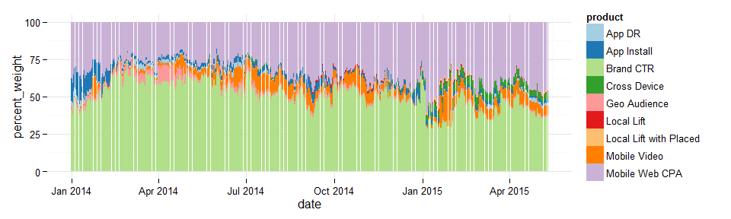

Product Breakdown Monthly

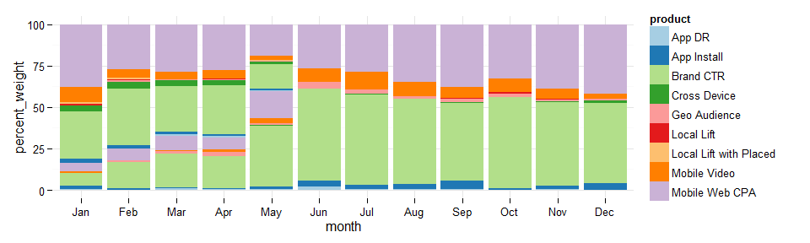

Product Trends

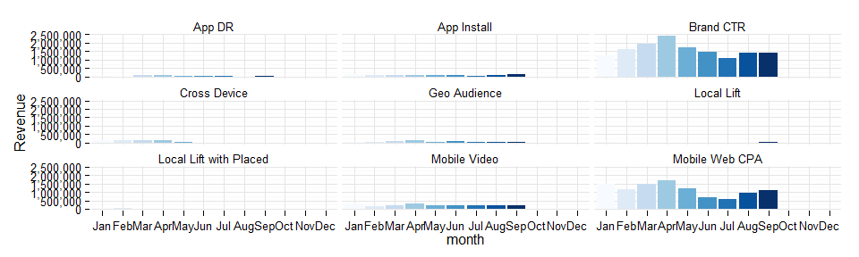

Monthlies by Mobile Initiative

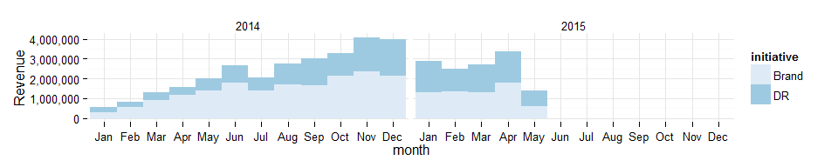

Monthly Device Proportions

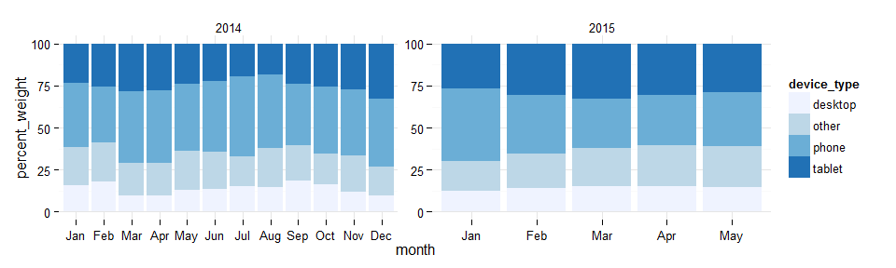

Monthly Device Type Trends

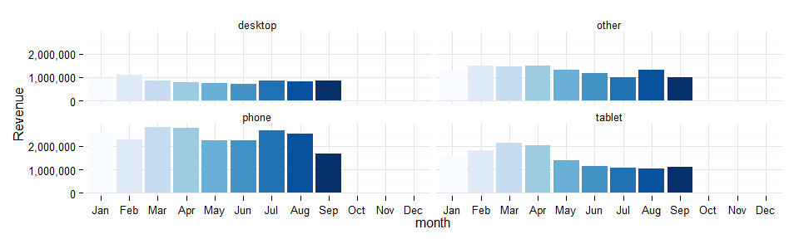

Roadmap

margin in lieu of cost in revene / cost chart(1)

product sold-as / ran-as by region, i.e. what products are driving growth? what's working where?

product by device sold-as / ran-as

sold-as vs ran-as analysis

long-term device-type trend line graph

long-term device trend line graph

revenue, margin by device

margin by product

data tables on product and device

THIS HAS BEEN A TEAM DUBCAT PRODUCTION